published | Test 1
title | Test 2
product | Test 3
Audience | Test 4
search_terms | Australia, USA, UK
summary | Test 6
access_warning | Test 7
release_date | Test 1
reissue_date | Test 2
published_date | Test 3
duration | Test 4
course_series | Test 5
membership_level | Test 6
version_numbers | Test 7
collect_feedback | Test 1
editing_division | Test 2
editing_department | Test 3
study_access | Test 4
study_division | Test 5
study_department | Test 6

Contents
published 0
Summary 1
Description 1
Another test 2

Summary
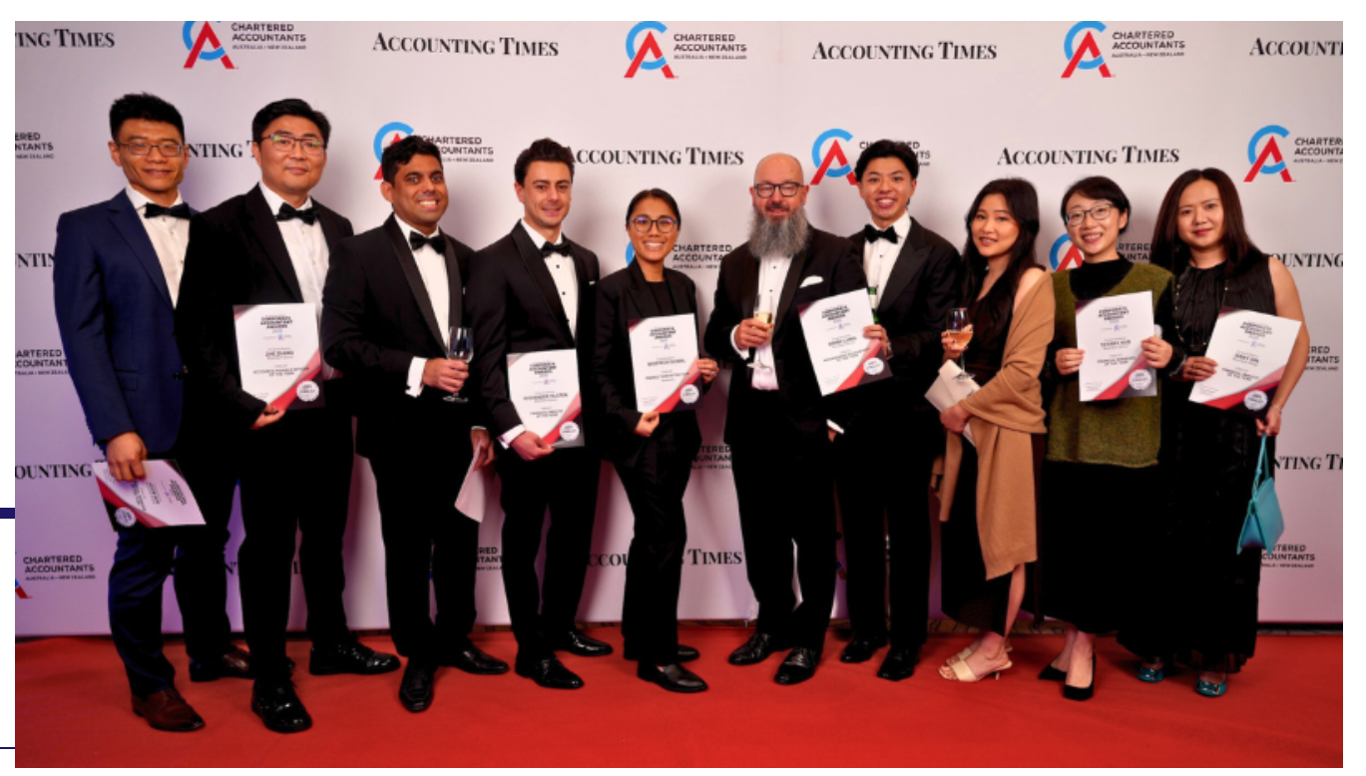
Our people and teams around the world are aligned in our strong vision to be the operating system for global trade and logistics.

Description
They faced impressive competition from representatives across a range of businesses, but their exceptional talent and commitment shone through.
The winners:
- Maria Ruiz – Corporate Accountant of the Year (Technology)
- Jenny Qin – Financial Analyst of the Year
- Donnie Ranti – Accounts Receivable Officer of the Year
A huge congratulations to each of the winners for this prestigious recognition, and for inspiring future finance professionals to consider a finance career in tech.

Another test
The WiseTech Finance team delivered a standout performance at the 2025 Corporate Accountant Awards last month, with three WiseTech team members taking home top honors.
The inaugural Corporate Accountant Awards, hosted by Accounting Times, highlights the incredible work achievements of in-house finance professionals in Australia.
Heading | Subheading
A | B
C | D
E | f

